Journal of Natural Science Review

Vol. x, No. x, year, pp-pp
https://kujnsr.com
e-ISSN: 3006-7804

Article title, no more than 15 words, Corbel font size 14, bold, left, sentence case

Author^{🖂1}, Author², Corbel Font Size 12, Sentence Case

¹ Affiliation, City/Province, Country, Corbel Font Size 10, Sentence Case
² Affiliation, City/Province, Country, Corbel Font Size 10, Sentence Case
🖂E-mail: author email address (corresponding author)

ABSTRACT |  | ARTICLE INFO
The abstract should be clear, informative, and written in one paragraph of 150-200 words. Use Corbel font in size 10-pt with single spacing. It should briefly describe your entire paper, which contains the introduction indicating the research gap, purpose, methodology, findings, and research implication. It should tell the prospective readers what you did and highlight the key findings. Avoid using technical jargon and uncommon abbreviations. The abstract must appear on the top of the first page after the title, author(s) name, affiliation, and email address of corresponding author (who will handle correspondence at all stages of refereeing and publication, also post-publication; this responsibility includes answering any future queries about methodology and materials) of the article. Keywords are the labels of your manuscript and are critical to correct indexing and searching. They should be well selected and closely related to the topic to facilitate readers’ search and should represent the content and highlight the article. Use only abbreviations that are firmly established in the field. There must be 3-5 keywords (or phrases), and each of them should be separated by a semicolon (;). |  | Article history:  Received:  Revised:  Accepted:
Keywords:
First keyword; Second keyword; Third keyword; Fourth keyword; Fifth keyword
To cite this article: Last name, First name. (Year). Article title. Journal of Natural Science Review, Vol.(No.), pp-pp. DOI:

To link to this article: https://kujnsr.com/article/view/xxxx
Copyright © 2024 Author(s). This work is licensed under a Creative Commons Attribution-ShareAlike 4.0 International License.

Introduction
This section is an introduction to the article. Altogether, the article structure contains (a) Title; (b) Author(s) name, affiliation, and e-mail address of corresponding author; (c) Abstract; (d) Keywords; (e) Introduction; (f) Method; (g) Findings and discussion; (h) Conclusion; (i) Acknowledgements; (j) References; and (k) Appendices (if any). Therefore, the article should clearly describe the subject's background, the author’s work, including the method used, results, and concluding discussion on the importance of the work.
Manuscripts should be typed in Ms. Word doc., docx, or RTF format; using 12-pt Corbel; left, right, top, and bottom margins are 2.5 cm; single-spaced on A4-sized paper; length: between 5,000 and 7,000 words (excluding Abstract, References, and Appendices if any). It is expected that the author(s) will submit written and proofread materials carefully.
Use Reference Management Software, such as Zotero (http://www.zotero.org), Mendeley (https://www.mendeley.com), etc. for citations and references by following the style of the American Psychological Association (APA) 7th Edition. Careful checking for spelling and grammatical errors should be performed. It is suggested to use Grammar Checker Software, Grammarly (http://app.grammarly.com).
The introduction should clearly state the purpose of the article. It includes a review of related literature and research purpose in essay style. The introduction should include key references to appropriate work. It states the significant contribution of the research. This section should be presented in the form of paragraphs, not pointers, and with a proportion of 15-20% of the whole article length.
Author(s) should provide an adequate background and literature review in order to record the existing solutions/method, to show which is the best of previous studies, to show the main limitation of the previous studies, to show what do you hope to achieve (to solve the limitation), and to show the scientific merit or novelties of the paper. Avoid a detailed literature review or a summary of the results. Do not describe literature review as author by author but it should be presented as group of articles per method or topic reviewed which refers to some literature.
At the end of the introduction, author(s) should explicitly state the research gaps and demonstrate the novelty of the research. Author(s) should also write the research questions or research objectives and the research contributions. Here are several examples of the gap analysis statement at the end of the Introduction section: “A few researchers focused on ….. There have been limited studies concerned on ….. Therefore, this research intends to ….. The objectives of this research are ….. This research aims to …..”

Method
This section discusses the research methodology. The Method consists of the research design, setting and participants or data source, data collection (practical procedures), and data analysis (practical procedures). Methods already published should be indicated by a reference; only relevant modifications should be described. Do not repeat the details of established methods. The Method section can be a unified form or using sub-sections.
In the Method section, the proportion is 10-15% of the total article length, all presented in the form of paragraphs. All text paragraphs should be single-spaced. Double spacing should NOT be used anywhere in the manuscript.

Findings and discussion
Sub-finding and discussion 1
The Findings and discussion section consists of a description of the results of the data analysis to answer the research question(s) and their meanings seen from current theories and references of the area addressed. The proportion of this section is 40-60% of the total article length. Please highlight differences between your results or findings and the previous publications by other researchers.
The Findings and discussion should be presented in sub-sections with the detail explanation of the findings. This section should be written objectively and factually, and without expressing personal opinion. It includes numbers, tables, and figures (e.g., charts and graphs). Number tables and figures consecutively in accordance with their appearance in the text (Table 1, Table 2, Table 3, Figure 1, Figure 2, Figure 3, etc.).
Table 1. An example of a table (font size 10pt)
An example of a heading | Column A | Column B
Add an entry | Row 1 | Row 1
Add an entry | Row 2 | Row 2
Add an entry | Row 3 | Row 3
Place titles of Tables preceding them and of Figures after the figures using Corbel font size 10, centered.
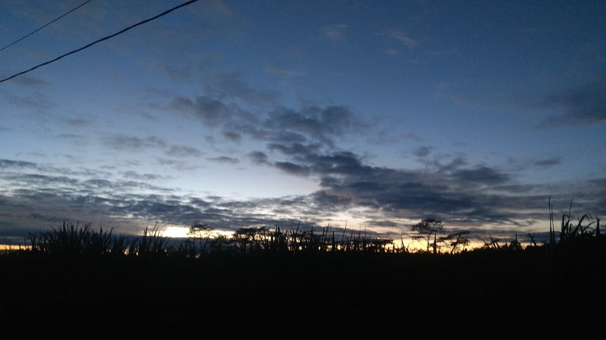

Figure 1. An example of a figure (font size 10pt)
Table 1, Table 2, Table 3, Figure 1, Figure 2, Figure 3, etc. should be explained with further elaborations. Please refer to APA for in-text citations and referencing (Author1 & Author2, 2021). For in-text citations, indicate the author’s last name and year (Author, 2015), and page number should be available for direct quotations such as “the construction of an artifact” (Fang & Widodo, 2019, p. 5). Citing more than one references should be alphabetically ordered (Canale, 2016; Kusumaningputri & Widodo, 2018). Referencing up to five authors needs to write all the names in the first citation (Author1, Author2, Author3, Author4, & Author5, 2021), and subsequently write the first author et al. followed by year (Author1 et al., 2021). Do not use footnotes.

Sub-finding and discussion 2
This sub-section deals with the second finding of the study. The author is required to present the results of the study with a detailed explanation. The findings should be followed by discussion directly. The discussion following the findings allows author(s) to offer interpretation and explain the meaning of study results. Emphasize any theoretical or practical consequences of the results.
The discussion should compare and contrast the findings of the current research with those from the previous studies or the supporting theories. There should be a similarity and contrast analysis. The following components should be covered in discussion: (a) How do your results relate to the original question or objectives outlined in the Introduction section? What is your finding of research? (what/how)? (b) Do you provide interpretation scientifically for each of your results or findings presented (why)? This scientific interpretation must be supported by valid analysis and characterization (why)? (c) Are your results consistent with what other investigators have reported (what else)? Or are there any differences?

Conclusion
The Conclusion section consists of the summary, restatement of the main findings. It should state concisely the most important propositions of the paper as well as the author’s views of the practical implications of the result. Tell how your work advances the field from the present state of knowledge. Without a clear conclusion, reviewers and readers will find it difficult to judge the work, and whether or not it merits publication in the journal. Do not repeat the Abstract, or just list obtained findings. Provide a clear scientific justification for your work, and indicate possible applications and extensions. You can also suggest future research and point out those that are underway.

Acknowledgements
This section indicates authors’ appreciation to funding agencies or those who helped in the research, including individuals who have assisted you in your research. For example, you may write, “We would like to acknowledge …..”

References
This section deals with references. Every source cited in the body of the article should appear in the list of References, and all sources appearing in the list of References should be cited in the body of the article. The references should be more up-to-date (published in the last 5 years). The primary sources cited in your paper are in the forms of journal articles, proceedings, research reports including theses and dissertations that can be accessed online (show the permalink/DOI). There should be at least 80% of the total references cited should be taken from journal articles (primary sources). Check each reference against the source (author name, year, volume, issue, permalink/DOI). Use other published articles in the same journal as models. The References should be presented alphabetically and chronologically and be set to 12-pt Corbel font, justified, with single line spacing and hanging indent as on the following examples:
Atmazaki, Ali, N. B. V., Muldian, W., Miftahussururi, Hanifah, N., Nento, M. N., & Akbari, Q. S. (2017). Panduan gerakan literasi nasional [National literacy movement guidelines]. Ministry of Education and Culture of the Republic of Indonesia.
Aunurrahman, Hamied, F., & Emilia, E. (2017). Realizing a good education in an Indonesian university context. In A. G. Abdullah, I. Hamidah, S. Aisyah, A. A. Danuwijaya, G. Yuliani, & H. S. H. Munawaroh (Eds.), Ideas for 21st Century Education: Proceedings of the Asian Education Symposium (AES 2016) (pp. 297–300). Routledge. https://doi.org/10.1201/9781315166575
Canale, G. (2016). (Re)searching culture in foreign language textbooks, or the politics of hide and seek. Language, Culture and Curriculum, 29(2), 225–243. https://doi.org/10.1080/07908318.2016.1144764
Durrant, J. (2020). Teacher agency, professional development and school improvement. Routledge.
Fang, F. (2018). Glocalization, English as a lingua franca and ELT: Re-conceptualizing identity and models for ELT in China. In B. Yazan & N. Rudolph (Eds.), Criticality, teacher identity, and (in)equity in ELT through and beyond binaries: Issues and Implications (pp. 23–40). Springer.
Fang, F., & Widodo, H. P. (Eds.). (2019). Critical perspectives of global Englishes in Asia: Language policy and curriculum, pedagogy, and assessment. Multilingual Matters. https://doi.org/10.21832/9781788924108-003
Gentles, S., Charles, C., Ploeg, J., & McKibbon, K. A. (2015). Sampling in qualitative research: Insights from an overview of the methods literature. The Qualitative Report, 20(11), 1772–1789. https://nsuworks.nova.edu/tqr/vol20/iss11/5
Heigham, J., & Croker, R. A. (2009). Qualitative research in applied linguistics: A practical introduction. Palgrave MacMillan.
Humphries, S. C., Burns, A., & Tanaka, T. (2015). “My head became blank and I couldn’t speak”: Classroom factors that influence English speaking. The Asian Journal of Applied Linguistics, 2, 164-175. https://caes.hku.hk/ajal/index.php/ajal/article/view/230
Kusumaningputri, R., & Widodo, H. P. (2018). Promoting Indonesian university students' critical intercultural awareness in tertiary EAL classrooms: The use of digital photograph-mediated intercultural tasks. System, 72, 49-61. https://doi.org/10.1016/j.system.2017.10.003
Mosek, E. (2017). Team flow: The missing piece in performance [Doctoral dissertation, Victoria University]. Victoria University Research Repository. http://vuir.vu.edu.au/35038/
Rose, H., & Galloway, N. (2019). Global Englishes for language teaching. Cambridge University Press.
Stevens, R. (2015). Role-play and student engagement: Reflections from the classroom. Teaching in Higher Education, 20, 481-492. https://doi.org/10.1080/13562517.2015.1020778
Wang, C., & Burris, M. A. (1997). Photovoice: Concept, methodology, and use for participatory needs assessment. Health Education & Behavior, 24(3), 369-387. https://doi.org/10.1177%2F109019819702400309
Widodo, H. P. (2016). Teaching English for specific purposes (ESP): English for vocational purposes (EVP). In W. A. Renandya & H. P. Widodo (Eds.), English language teaching today (pp. 277-291). Springer.
Widodo, H. P., Fang, F., & Elyas, T. (2020). The construction of language teacher professional identity in the Global Englishes territory: ‘We are legitimate language teachers’. Asian Englishes, 22(3), 1-8. https://doi.org/10.1080/13488678.2020.1732683
Widodo, H. P., & Ferdiansyah, S. (2018). Engaging student teachers in video-mediated self-reflection in teaching practica. In K. J. Kennedy & J. C-K. Lee (Eds.), The Routledge handbook of schools and schooling in Asia (pp. 922-934). Routledge.

Suggested Reviewers
Please suggest 3-5 reviewers for this article. We may select reviewers from the list below in case we have no appropriate reviewers for this topic.

Name: Abdul Qayeum Karim | E-mail: aqkarim19@gmail.com
Affiliation: Ph.D .Prof. Dept. of Civil, Faculty of Engineering, Kabul University, Kabul 1006, Afghanistan

Name: Abdul Ghias Safi | E-mail:
Affiliation: Prof. Dept. of HYDRO-METEOROLOGY, Faculty of GEO SCIENCE, Kabul University, Kabul 1006, Afghanistan

Name: | E-mail:
Affiliation:

Name: | E-mail:
Affiliation:

Name: | E-mail:
Affiliation:

