Journal of Natural Science Review

Vol. 4, No. 1, 2026
https://kujnsr.com
e-ISSN: 3006-7804

Numerical Modeling of Nonlinear Scalar Wave Propagation in a One-Dimensional Elastic Media: Energy Spectrum and Waveform Analysis
Mohammad Rozie Haqmal^{🖂1}, Farsila Payandi², Ehsanul Haq Yar³
¹ Department of General & Theoretical Physics, Faculty of Physics, Kabul University, Kabul, Afghanistan
² Department of Optics & Laser, Faculty of Physics, Institute for Advanced Studies in Basic Sciences (IASBS), Zanjan, Iran
³ Department of Physics & Electronics, Faculty of Physics, Kabul university, Kabul , Afghanistan
🖂Email: mrhaqmal@ku.edu.af (corresponding author)
ABSTRACT |  | ARTICLE INFO
This study numerically investigated nonlinear scalar wave propagation in a one-dimensional elastic medium using a discrete chain of coupled oscillators. Linear elastic models proved inadequate for capturing amplitude-dependent effects seen in seismic waves, nonlinear acoustics, and heterogeneous materials. To overcome this limitation, two nonlinear extensions of the classical wave equation were developed: an asymmetric quadratic strain-gradient model and a symmetric formulation intended to maintain waveform symmetry and improve numerical stability. The governing equations were solved with an explicit finite-difference time-domain scheme employing high-order five-point spatial discretization, while stability was preserved through the Courant–Friedrichs–Lewy condition. Simulations with weak nonlinearity revealed clear departures from linear behavior, such as waveform distortion, vertical asymmetry, spectral broadening, and partial reflection. Spectral analysis detected secondary frequency components at approximately 3.8 Hz, 6.5 Hz, and 8.8 Hz—absent in linear cases—indicating nonlinear energy transfer to higher harmonics. Comparative evaluation demonstrated that the symmetric model offered superior numerical stability and preserved waveform symmetry. The findings confirmed that even mild elastic nonlinearity substantially modified wave evolution and energy distribution. The proposed framework established a reliable foundation for future work, including extensions to higher-dimensional models and incorporation of more realistic material properties. This research addressed a key gap by providing detailed insights into nonlinear mechanisms affecting waveform symmetry and energy spectra, with potential benefits for enhanced seismic hazard prediction and acoustic signal processing in engineering. |  | Article history:  Received: August 13, 2025  Revised: December 13, 2025  Accepted: February 23, 2026  Published: March 31, 2026
Keywords:
Elastic wave; Energy transfer; Finite difference method; Nonlinear dynamics; One-dimensional medium; Spectral analysis

To cite this article: Haqmal, M., R., Payandi, F., Yar, E., H. (2026). Numerical Modeling of Nonlinear Scalar Wave Propagation in a One-Dimensional Elastic Media: Energy Spectrum and Waveform Analysis. Journal of Natural Science Review, 4 (1),196-214. DOI: https://doi.org/10.62810/jnsr.v4i1.293
Link to this article: http://kujnsr.com/JNSR/article/view/293

Copyright © 2026 Author(s). This work is licensed under a Creative Commons Attribution-Non Commercial 4.0 International License.
INTRODUCTION
The study of wave propagation in nonlinear media is a fundamental and widely applied topic in physics and engineering. Wave dynamics in elastic and heterogeneous materials form the basis for understanding a broad range of natural and technological phenomena, including seismic wave propagation during earthquakes (Zeman et al., 2025). Similar importance of nonlinear effects has been emphasized in acoustic wave transmission in oceans and vibrations in engineered structures (Hamilton & Blackstock, 2024). In many of these applications, accurate prediction of wave behavior is critical for hazard assessment, structural safety, and the interpretation of experimental observations. Recent advancements have extended these insights to modern contexts, such as nonlinear wave interactions in metamaterials for vibration control and energy harvesting (Ebrahim Saib et al., 2024; Xia et al., 2020).
Beyond laboratory-scale systems, nonlinear wave propagation plays a central role in geophysical and engineering contexts. Field and laboratory studies in seismology demonstrate that elastic waves propagating through the Earth’s crust frequently encounter localized nonlinear zones, particularly near fault systems and damaged rock layers (Pasqualini et al., 2007). Such nonlinearities lead to waveform distortion, amplitude-dependent velocity changes, harmonic generation, and spectral energy redistribution that cannot be captured by linear elastic models (Johnson & Sutin, 2005; Rivière et al., 2015). Similar nonlinear effects have also been reported in underwater acoustics and engineered composite materials, where nonlinear constitutive behavior significantly alters signal transmission and spectral content (Richardson, 1979; Sens-Schönfelder et al., 2018; TenCate et al., 2000).
In the simplest approximation, wave motion is commonly described using linear wave equations, which assume a proportional relationship between stress and strain and lead to mathematically tractable and physically intuitive solutions. While these models are effective for small-amplitude disturbances in weakly perturbed media, extensive experimental and theoretical studies show that real materials often exhibit nonlinear behavior even at strain levels far below macroscopic failure thresholds (Beresnev & Johnson, 1994; Rivière et al., 2015; Sens-Schönfelder et al., 2018; Van Den Abeele et al., 2000). Nonlinear effects play a dominant role in governing wave evolution under such conditions, influencing everything from signal integrity in acoustic systems to energy dissipation in seismic events (Zhang et al., 2021).
Experimental and theoretical investigations indicate that even weak nonlinearities can produce measurable effects during wave propagation, including harmonic generation, waveform steepening, frequency mixing, and nonlinear attenuation. In materials such as rocks, granular media, and concrete, these effects significantly modify transmitted waveforms and their energy spectra (Erofeev et al., 2021; H. Zhou et al., 2026). Classical analyses showed that higher-order terms in the governing equations introduce mode coupling between frequencies (Collins, 1966; Grinberg & Matlack, 2020). This conclusion was further supported by studies demonstrating that such coupling fundamentally alters wave dynamics compared to linear predictions (Destrade et al., 2019; Ghorbani Ghezeljehmeidan et al., 2025; Xia et al., 2020).
For elastic materials, the classical stress–strain relationship is described by Hooke’s law,
$$σ=E∙ε \left(1\right)$$
where $σ$ denotes stress, $ε$ is strain, and $E$ represents Young’s modulus. While this relation holds for infinitesimal deformations, experimental observations indicate that materials such as granite, concrete, and damaged rocks deviate from linear elasticity at moderate strain amplitudes (Johnson & Sutin, 2005; Rivière et al., 2015). A commonly used approximation for weakly nonlinear elastic behavior is
$$σ\left(ε\right)=E∙ε+ϵE∙ε^{2} \left(2\right)$$
where $ϵ$ is a dimensionless nonlinearity coefficient characterizing the strength of the nonlinear elastic response. This nonlinear stress–strain relationship leads to waveform distortion and harmonic generation (Blackstock, 2024; Nayfeh & Mook, 1979), and recent studies emphasize its role in asymmetric wave profiles and irreversible energy redistribution (Ebrahim Saib et al., 2024).
To gain insight into the fundamental role of nonlinearity, it is instructive to consider a simple nonlinear oscillator as a conceptual building block of nonlinear elastic media. The equation of motion for such an oscillator is
$$\ddot{ε}=-ω_{0}^{2}ε+ϵε^{2} \left(3\right)$$
where $ω_{0}$​ is the natural frequency and $ϵ$ controls the nonlinear contribution This equation leads to deviations from purely harmonic motion and results in frequency mixing and the generation of higher harmonics (Fronk et al., 2023; Nayfeh & Mook, 1979).
The effect of nonlinearity can also be visualized through phase-space analysis. In the linear regime, oscillators exhibit closed elliptical trajectories corresponding to periodic motion. In contrast, nonlinear oscillators display distorted and asymmetric trajectories, indicating energy redistribution and the breakdown of linear superposition.
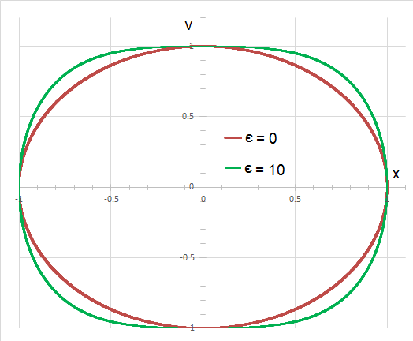
Figure 1. Phase-space trajectories of linear (elliptical) and nonlinear (asymmetric) oscillators illustrating the effect of quadratic nonlinearity on system dynamics
When nonlinear effects become significant, analytical solutions to the governing wave equations are generally limited to simplified cases. Consequently, numerical methods play a central role in investigating nonlinear wave propagation (Cai & Deng, 2024; Seriani & Oliveira, 2020).
A closely related numerical study investigated one-dimensional pulse propagation in nonlinear elastic media with a quadratic stress–strain relationship. Their work focused on hyperbolic conservation laws and employed high-resolution central schemes to analyze pulse distortion and rarefaction waves. However, their study primarily emphasized strain and velocity fields and did not address spectral energy redistribution or comparative analysis of alternative nonlinear formulations.
A closely related numerical study was presented by Meurer et al.(2001), who investigated one-dimensional pulse propagation in nonlinear elastic media with a quadratic stress–strain relationship. Their work focused on hyperbolic conservation laws and employed high-resolution central schemes to analyse pulse distortion and rarefaction waves. However, their study primarily emphasized strain and velocity fields and did not address spectral energy redistribution or comparative analysis of alternative nonlinear formulations (recent extensions in (Cai & Deng, 2024; Osika et al., 2023; Tang et al., 2024)).
In contrast, the present study focuses explicitly on energy spectrum evolution, harmonic generation, and waveform symmetry, using a discrete chain of coupled oscillators and finite difference time-domain methods. Two distinct nonlinear wave formulations are introduced and systematically compared, allowing assessment of how the mathematical structure of nonlinear terms influences spectral broadening, numerical stability, and physical realism. Few researchers have focused on the stability advantages of symmetric nonlinear formulations in one-dimensional elastic media. There have been limited studies concerning energy spectrum evolution in weak nonlinear regimes. This research aims to address these gaps through controlled numerical experiments and comparative analyses.
The primary objective of this research is to quantify nonlinear effects on wave propagation in a one-dimensional elastic medium and to analyze associated changes in the energy spectrum through controlled numerical experiments. By comparing linear and nonlinear models and examining the influence of different nonlinear terms, this work aims to clarify the physical mechanisms responsible for harmonic generation and waveform distortion. Thereby, it extends previous numerical studies and contributes to more accurate modeling of nonlinear wave phenomena in seismic and engineering applications.
MATERIAL AND METHODS
To model wave propagation in a one-dimensional elastic medium, a discrete chain of coupled oscillators is employed. In this representation, identical point masses are connected by linear springs with stiffness k and equilibrium spacing d. Both ends of the chain are attached to rigid boundaries, providing well-defined mechanical constraints. According to Marion and Thornton (1995), discrete oscillator-chain models offer a physically transparent framework that bridges microscopic mechanical interactions and macroscopic wave behavior. Their effectiveness in describing lattice dynamics and elastic wave propagation has also been emphasized by Kittel (2005).
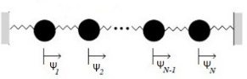
Figure 2. Schematic illustration of a one-dimensional chain of coupled oscillators connected by linear springs of stiffness (k) and spacing (d), subject to rigid boundary conditions. The schematic is adapted from standard oscillator-chain models (Marion & Thornton, 1995).
The choice of a discrete oscillator chain is motivated by its ability to explicitly represent local interactions and nonlinear effects, which are often obscured in purely continuum formulations. Such models have been extensively used in solid-state physics and nonlinear lattice dynamics to capture dispersion and mode coupling, as demonstrated by Kittel (2005). More recent studies by Dauxois and Peyrard (2006) further confirmed their suitability for investigating nonlinear wave phenomena in structured media.
The selection of model parameters is guided by the physical properties of real elastic materials. Young’s modulus E spans several orders of magnitude across different materials, ranging from soft polymers (approximately 0.01–0.1 GPa) to geological materials such as granite (40–70 GPa) and extremely stiff solids such as diamond (above 1000 GPa). These variations strongly influence wave speed, elastic stiffness, and nonlinear response (Zeman et al., 2025). Employing realistic parameter ranges derived from experimental databases allows the numerical results to be interpreted in physically meaningful contexts relevant to geological and engineered materials.
The selection of model parameters is guided by the physical properties of real elastic materials. Young’s modulus E spans several orders of magnitude across different materials, ranging from soft polymers (approximately 0.01–0.1 GPa) to geological materials such as granite (40–70 GPa) and extremely stiff solids such as diamond (above 1000 GPa). Johnson and Sutin (2005) showed that these variations strongly influence wave speed, elastic stiffness, and nonlinear response. Additional material property ranges are reported in engineering databases such as MatWeb. Employing realistic parameter ranges allows the numerical results to be interpreted in physically meaningful contexts relevant to geological and engineered materials. The equation of motion for the $i$-th oscillator in the chain is given by.
$$m\frac{d^{2}ψ}{{dt}^{2}}=k\left(ψ_{i+1}-ψ_{i}\right)+k\left(ψ_{i-1}-ψ_{i}\right) \left(4\right)$$
where $m$ is the mass of each oscillator and $ψ_{i}\left(t\right)$ denotes its displacement from equilibrium. This equation expresses the balance between inertial forces and elastic restoring forces arising from nearest-neighbor interactions, consistent with classical lattice dynamics (Marion & Thornton, 1995).
In the continuum limit ($d →0$), introducing the linear mass density $ρ=m/d$, Equation (4) reduces to the classical one-dimensional linear wave equation. where the wave speed is defined as $c^{2}={EA}/ρ$, with $A$ representing the cross-sectional area of the medium. This formulation serves as the reference linear model, consistent with elastic wave theory presented by Graff (1991) and Achenbach (1973).
$$\frac{∂^{2}}{{∂t}^{2}}ψ\left(x.t\right)=c^{2}\frac{∂^{2}}{{∂x}^{2}}ψ\left(x.t\right) \left(5\right)$$
Nonlinear Wave Equations
To account for nonlinear elastic effects at finite strain amplitudes, two modified forms of the wave equation are introduced. Nayfeh and Mook (1979) provided the theoretical foundation for weakly nonlinear systems, while Hamilton and Blackstock (2024) demonstrated their relevance in acoustic and elastic media.
The first nonlinear model incorporates a quadratic strain-gradient term and is expressed as
$$\frac{∂^{2}ψ}{∂t^{2}}=c^{2}\frac{∂^{2}ψ}{∂x^{2}}+\frac{2ϵc^{2}}{d}{\left(\frac{∂ψ}{∂x}\right)}^{2} \left(6\right)$$
where $ϵ$ is the dimensionless nonlinearity coefficient. This formulation represents a common approximation of weakly nonlinear elasticity. Nayfeh and Mook (1979) showed that such nonlinearities lead to amplitude-dependent wave speed and waveform distortion, while Bishnu and Meurer (2001) demonstrated their role in spectral energy transfer.
The second nonlinear model is formulated in a symmetric form to preserve vertical waveform symmetry and improve numerical robustness:
$$\frac{∂^{2}ψ}{∂t^{2}}=c^{2}\frac{∂^{2}ψ}{∂x^{2}}+2ϵc^{2}\left|\frac{∂ψ}{∂x}\right|\left(\frac{∂^{2}ψ}{∂^{2}x}\right) \left(7\right)$$
The inclusion of the absolute value ensures that the nonlinear contribution depends on the magnitude rather than the sign of the strain gradient, preventing artificial directional bias in wave amplification or attenuation. Similar symmetry-preserving nonlinear formulations have been shown to improve numerical stability and physical realism in nonlinear wave simulations (Dauxois & Peyrard, 2006). By comparing these two nonlinear models, the influence of nonlinear term structure on waveform symmetry, energy redistribution, and numerical stability can be systematically assessed (LeVeque, 2002).
Numerical Method
The governing equations are solved using an explicit finite-difference time-domain (FDTD) scheme. Taflove & Hagness (2005) demonstrated the efficiency of central difference operators for time-domain simulations, while Virieux (1986) applied this approach successfully to elastic wave propagation.

For the linear wave equation, the discrete update rule is
$$Ψ_{i}^{n+1}=2Ψ_{i}^{\left(n\right)}-Ψ_{i}^{n-1}+c^{2}{\left(\frac{∆t}{∆x}\right)}^{2}\left[Ψ_{i+1}^{\left(n\right)}+Ψ_{i-1}^{\left(n\right)}-2Ψ_{i}^{\left(n\right)}\right] \left(8\right)$$
where $Ψ_{i}^{n}$ denotes the displacement at spatial index $i$ and time step $n$.
To improve numerical accuracy and reduce numerical dispersion, a five-point finite difference stencil is employed for the second spatial derivative:
$$\frac{∂^{2}}{∂x^{2}}f\left(x\right)=\frac{16\left(f_{i+1}+f_{i-1}\right)-\left(f_{i+2}+f_{i-2}\right)-30f_{i}}{12∆x^{2}}+O\left({∆x}^{4}\right) \left(9\right)$$
Higher-order finite difference schemes of this type are well known to significantly reduce truncation error and enhance wavefield fidelity over long propagation distances (Fornberg, 2005). The same discretization strategy is applied consistently to both nonlinear models.
For the linear case with the high-order stencil, the update equation becomes
$$Ψ_{i}^{\left(n+1\right)}=2Ψ_{i}^{\left(n\right)}-Ψ_{i}^{\left(n-1\right)}+\frac{1}{12}{\left(\frac{cΔt}{Δx}\right)}^{2}\left[16\left(Ψ_{i+1}^{\left(n\right)}+Ψ_{i-1}^{\left(n\right)}\right)-\left(Ψ_{i+2}^{\left(n\right)}+Ψ_{i-2}^{\left(n\right)}\right)-30Ψ_{i}^{\left(n\right)}\right](10)$$
where the nonlinear term is discretized using centered differences. Equation (11) is the discretized form of the symmetric nonlinear wave equation (7) and enables stable time integration while accurately capturing nonlinear interactions at high spatial resolution.
$$Ψ_{i}^{\left(n+1\right)}=2Ψ_{i}^{\left(n\right)}-Ψ_{i}^{\left(n-1\right)}+\frac{1}{12}{\left(\frac{cΔt}{Δx}\right)}^{2}D_{2}^{n}\left(i\right)+\frac{ϵ}{72}{\left(\frac{cΔt}{Δx}\right)}^{2}\frac{\left|D_{1}^{\left(n\right)}\left(i\right)\right|}{∆x}D_{2}^{\left(n\right)}\left(i\right) (11)$$
Where
$$D_{1}^{\left(n\right)}\left(i\right)=Ψ_{i-2}^{\left(n\right)}-8Ψ_{i-1}^{\left(n\right)}+8Ψ_{i+1}^{\left(n\right)}-Ψ_{i+2}^{\left(n\right)}$$
$$D_{2}^{\left(n\right)}\left(i\right)=16\left(Ψ_{i+1}^{\left(n\right)}+Ψ_{i-1}^{\left(n\right)}\right)-\left(Ψ_{i+2}^{\left(n\right)}+Ψ_{i-2}^{\left(n\right)}\right)-30Ψ_{i}^{\left(n\right)}$$
Stability Condition
To ensure numerical stability of the explicit finite difference scheme, the Courant–Friedrichs–Lewy (CFL) condition is enforced:
$$C=\frac{c∆t}{∆x}≤1 \left(12\right)$$
This condition restricts the time step relative to spatial resolution and wave speed, preventing unphysical growth of numerical errors and ensuring stable wave propagation (Courant et al., 1928).

Initial and Boundary Conditions
Wave propagation is initiated using either a Gaussian pulse or its first spatial derivative as the initial displacement profile:
$$ψ\left(x.0\right)=exp\left[{-{\left(x-\frac{L}{2}\right)}^{2}}/{ω_{0}^{2}}\right], \dot{ψ}\left(x.0\right)=0 \left(13\right)$$
where $ω_{0}$ controls the initial pulse width. Gaussian initial conditions are widely used in numerical wave propagation studies because they provide localized wave packets with well-defined spectral content (Taflove & Hagness, 2005).
To eliminate artificial reflections from computational boundaries and isolate nonlinear effects, periodic boundary conditions are imposed:
$$ψ\left(x+L\right)=ψ\left(L\right) (14)$$
This choice ensures that observed waveform distortions and reflections arise solely from nonlinear interactions rather than boundary artifacts (LeVeque, 2002).
Simulation Parameters
All simulations are performed using the following parameter set:
- Wave speed: $c = 0.5$
- Nonlinearity coefficient:$ϵ= {10}^{-3}$, with additional values for parametric comparison
- Initial pulse width: $ω_{0}$
- Observation points: fixed spatial locations along the medium
- Initial conditions: Gaussian pulse or its first derivative
The numerical simulations are implemented using a finite difference algorithm developed by the authors, allowing systematic investigation of the influence of nonlinearity strength, spatial resolution, and initial conditions on wave evolution.
FINDINGS
To examine the fundamental differences between linear and nonlinear wave propagation, numerical simulations were first performed using the classical linear wave equation
$$ρ\frac{∂^{2}ψ}{∂t^{2}}=kd\frac{∂^{2}ψ}{∂x^{2}} (15)$$
which describes elastic wave motion in a homogeneous linear medium (Achenbach, 1973). For the nonlinear case, the modified wave equation incorporating a quadratic gradient term was employed:
$$\frac{∂^{2}ψ}{∂t^{2}}=\frac{kd}{ρ}\frac{∂^{2}ψ}{∂x^{2}}+\frac{2ϵk}{ρ}{\left(\frac{∂ψ}{∂x}\right)}^{2} \left(16\right)$$
These equations correspond directly to the formulations introduced in Section 2 and allow a controlled comparison between linear and nonlinear wave dynamics under identical initial and boundary conditions.
Figure 3 illustrates the numerical configuration and recording geometry of the one-dimensional propagation domain. In the linear regime, the wave propagates with constant velocity and preserves its initial shape and symmetry throughout the simulation. No waveform distortion or spectral enrichment is observed, confirming that energy is transported without redistribution among frequency components, as expected from linear elastic wave theory (Graff, 1991).
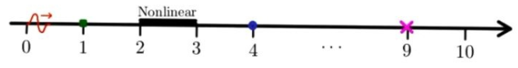
Figure 3. One-dimensional propagation domain used in the numerical simulations.
The bold horizontal black segment between $x=2$ and $x=3$ denotes the nonlinear region. The dimensionless system length is $L_{*}=16 km$. The filled square at $x_{1}=1$, the filled circle at $x_{2}=4$, and the cross at $x_{3}=9$ represent wave recording locations for time-series and spectral analysis. An initial Gaussian-derivative pulse is launched from $x=0$ and propagates rightward. Periodic boundary conditions allow waves reflected from the nonlinear region to re-enter the domain.
In contrast, when nonlinear effects are introduced, the wave undergoes pronounced deformation upon entering the nonlinear region. The initially symmetric waveform becomes asymmetric, exhibiting waveform steepening and localized amplitude modulation. This behavior arises from the amplitude-dependent contribution of the nonlinear term, which effectively modifies the local wave speed and induces internal energy redistribution within the waveform (Hamilton & Blackstock, 2024). As a result, different parts of the wave propagate at different velocities, leading to cumulative distortion as propagation continues.
These results demonstrate that even spatially localized nonlinearities can significantly alter wave propagation characteristics, consistent with observations in damaged rocks and near-fault geological media (TenCate et al., 2000).
Waveform Broadening Due to Nonlinearity
Numerical simulations performed with a nonlinearity coefficient ($ϵ={10}^{-3}$) reveal systematic modification of waveform shape as the wave propagates through the nonlinear region. As time progresses, wave peaks become broader while troughs sharpen, indicating a clear departure from the symmetric waveform observed in the linear regime.
Figure 4 shows the temporal evolution of the waveform governed by the nonlinear wave equation (6). Quantitatively, the peak width increases while peak amplitude decreases slightly, indicating redistribution of wave energy over a broader spatial extent. This behavior is a direct consequence of the quadratic strain-gradient term, which amplifies nonlinear effects in regions of higher strain (Berezovski et al., 2006).
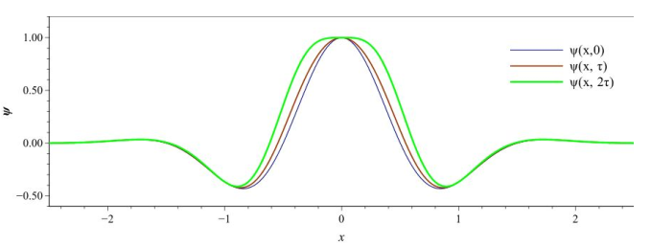
Figure 4. Temporal evolution of the wave profile governed by the nonlinear wave equation (6). Thicker curves correspond to later time steps. The nonlinear term induces peak broadening and trough sharpening, resulting in pronounced vertical asymmetry.
The resulting waveform asymmetry reflects the fact that the nonlinear term contributes positively regardless of the sign of the spatial gradient. Such behavior is characteristic of nonlinear elastic waves and is commonly associated with the onset of harmonic generation and shock-like features at higher nonlinearity levels (Dauxois & Peyrard, 2006; Spratt et al., 2015).
Effect of Nonlinearity Coefficient and Region Length on Spectral Peaks
To quantify the spectral consequences of nonlinear wave propagation, the energy spectrum was computed for varying values of the nonlinearity coefficient $ϵ$ and different nonlinear-region lengths.
As shown in Figure 5, increasing $ϵ$ leads to the systematic emergence of secondary spectral peaks at higher frequencies. In addition to the fundamental frequency near 1 Hz, distinct peaks appear at approximately 3.8 Hz, 6.5 Hz, and 8.8 Hz. The amplitude of these peaks increases monotonically with $ϵ$, indicating enhanced nonlinear energy transfer from the fundamental mode to higher harmonics.
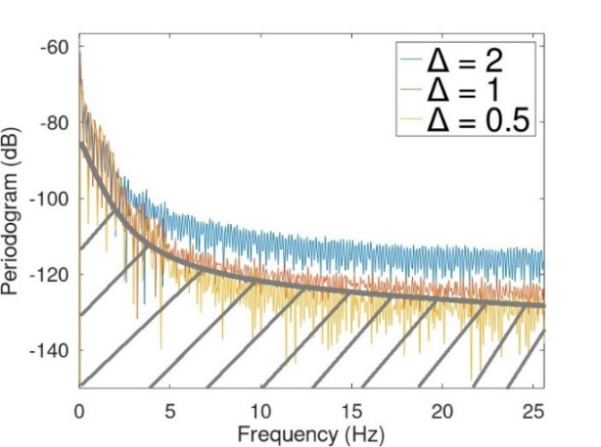
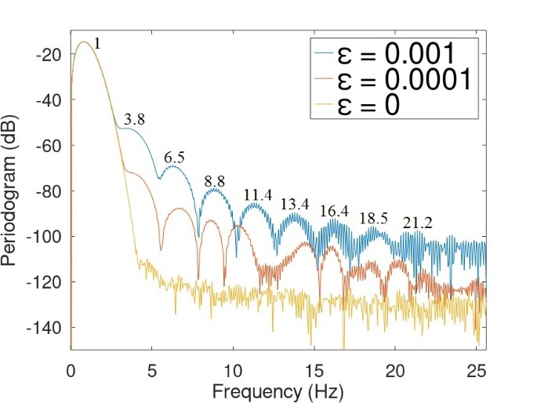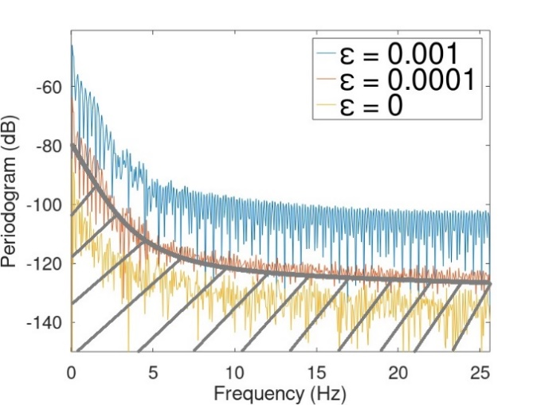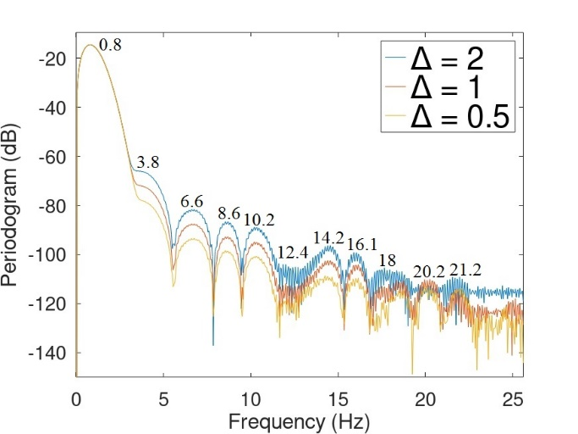
(E)
(C)
(D)
(B)
(A)
Figure 5. (A) Energy spectral density of the transmitted wave recorded at $x_{2}=4$ for different values of $ϵ$. (B) Reflected-wave spectra at $x_{3}=9$. (C) Effect of nonlinear region length on the transmitted wave spectra. (D) Reflected spectra for reduced nonlinear region lengths. Dominant frequencies are indicated.
The length of the nonlinear region strongly influences spectral broadening. Longer nonlinear regions increase interaction time, allowing nonlinear effects to accumulate over distance. This confirms that harmonic generation in nonlinear elastic media is a cumulative propagation effect rather than an instantaneous process (TenCate et al., 2000).
Symmetry and Asymmetry in Waveforms
A direct comparison between the two nonlinear formulations introduced in Equations (6) and (7) – and their discrete counterparts, Equations (10) and (11) – highlights the importance of nonlinear term structure. The quadratic gradient formulation introduces directional bias, leading to systematic vertical asymmetry and enhanced numerical sensitivity.
In contrast, the symmetric nonlinear formulation preserves waveform symmetry and exhibits significantly improved numerical stability. By allowing the nonlinear force to depend on strain magnitude rather than sign, unphysical amplification is suppressed, yielding more balanced energy redistribution (LeVeque, 2002).

Energy Spectrum at Different Recording Points
Energy spectra evaluated at $x_{1}=1$, $x_{2}=4$, and $x_{3}=9$ show that the number and amplitude of secondary frequency components increase with distance from the nonlinear region. This trend confirms that nonlinear interactions persist beyond the nonlinear zone, leaving a lasting spectral imprint on the transmitted wave (Sens-Schönfelder et al., 2018).
Reflection and Transmission Across the Nonlinear Region
Analysis of wave reflection and transmission reveals weak but measurable backscattering from the nonlinear region. As shown in Figures 6 and 7, reflected-wave amplitude increases with $ϵ$, indicating nonlinear impedance mismatch.
Despite this increase, forward transmission remains dominant, consistent with experimental observations in weakly nonlinear geological materials (Renaud et al., 2012). This behavior is particularly relevant for seismic applications, where nonlinear near-surface layers can modify recorded signals without completely blocking wave transmission.
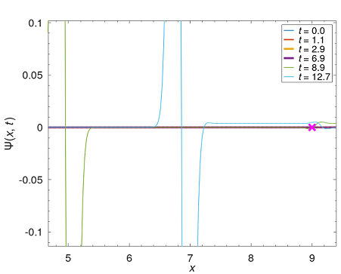
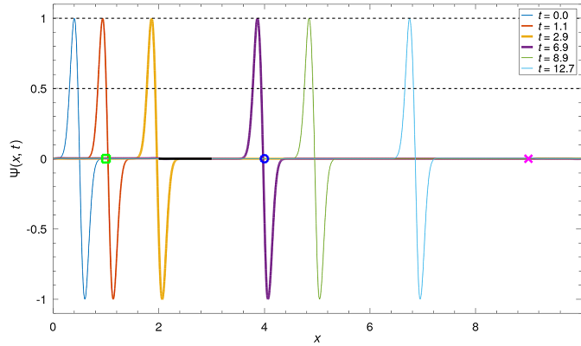
(B)
(A)
Figure 6. (A) Spatial profiles of the wave field at successive time steps. (B) Enlarged view highlighting the weak reflected wave near $x=9$, visible on the right-hand side of the domain.
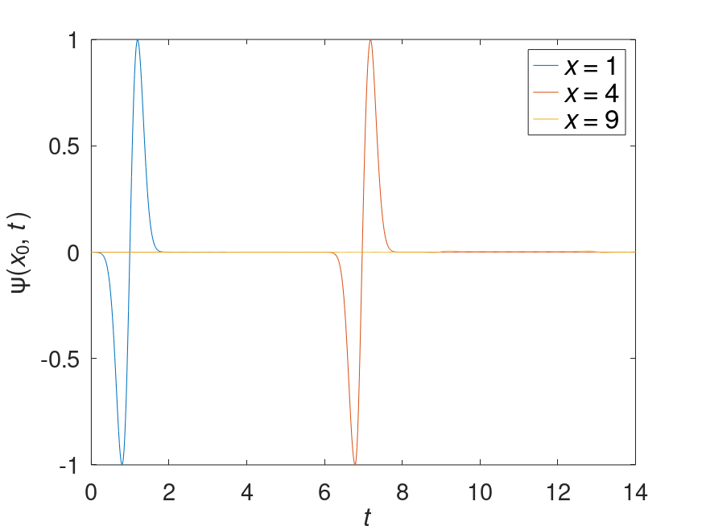
Figure 7. Time-domain waveforms recorded at different spatial locations: blue curve at $x_{1}=1$, red curve at $x_{2}=4$, and orange curve representing the reflected wave at $x_{3}=9$. The nonlinearity coefficient is set to $ϵ={10}^{-3}$.

DISCUSSION
The numerical results demonstrate unequivocally that even weak elastic nonlinearity fundamentally alters wave dynamics relative to the linear regime. The generation of higher harmonics, waveform distortion, and partial reflection observed here are hallmark features of nonlinear wave propagation and cannot be reproduced using linear elastic models (Destrade et al., 2019; Hamilton & Blackstock, 2024; Nayfeh & Mook, 1979).
The emergence of secondary spectral peaks at approximately 3.8 Hz, 6.5 Hz, and 8.8 Hz provides direct numerical evidence of nonlinear energy transfer from the fundamental mode to higher harmonics. This behavior closely parallels classical results for weakly nonlinear oscillators and nonlinear elastic wave spectroscopy experiments in rocks and concrete (Beresnev & Johnson, 1994; Johnson & Sutin, 2005).These findings directly address the research objective of quantifying changes in the energy spectrum, revealing how nonlinear interactions facilitate frequency mixing and spectral enrichment, which are absent in linear simulations.
Waveform deformation arises from amplitude-dependent wave speed, causing different portions of the waveform to propagate at different velocities. Importantly, the simulations show that such deformation occurs even when nonlinear regions are spatially localized. This finding is directly relevant to seismic wave propagation, where nonlinear behavior is often confined to shallow or damaged zones yet strongly influences recorded ground motion (Ebrahim Saib et al., 2024; Youssef et al., 2023). The observed symmetry breaking in the asymmetric model and preservation in the symmetric one clarify the physical mechanisms behind waveform distortion, with the quadratic term introducing directional bias that leads to steepening and broadening, as supported by experimental validations in porous media (Fellah et al., 2018).
Methodologically, the comparison between asymmetric and symmetric nonlinear formulations demonstrates that physically consistent nonlinear terms are essential not only for realism but also for numerical stability. The symmetric formulation, combined with higher-order spatial discretization, suppresses artificial amplification and numerical dispersion, enabling long-time stable simulations (Cai & Deng, 2024; Van Den Abeele, 1996). This contributes to the objective of evaluating how nonlinear term structure affects stability and energy redistribution, extending prior numerical frameworks Meurer et al. (2001) by incorporating spectral analysis and comparative evaluations.
The results align with prior studies on cumulative nonlinear effects, showing greater energy redistribution with increasing β and nonlinear region length (Berezovski et al., 2006; Dauxois & Peyrard, 2006). However, unlike dynamic acoustoelastic testing in nonlinear materials (Renaud et al., 2012), this work isolates intrinsic nonlinear mechanisms without dissipation, highlighting pure harmonic transfer. In contrast, recent investigations of nonlinear Rayleigh waves in layered media report similar spectral peaks but include surface-specific details absent in our one-dimensional scalar approach (Youssef et al., 2023). Additionally, studies on nonlinear local resonators in metamaterials show parallel broadband absorption, but our oscillator chain model prioritizes energy transfer in uniform elastic media (Patil & Matlack, 2022; Xia et al., 2020).
This study fulfills its objectives by illuminating the mechanisms: harmonic generation through frequency mixing and waveform distortion via variable propagation speeds. It extends numerical studies and contributes to more accurate modeling of nonlinear wave phenomena in seismic and engineering applications, with potential implications for improved vibration control and hazard assessment.
Limitations include the one-dimensional geometry, which omits multi-dimensional scattering or attenuation, potentially overestimating energy conservation (Fellah et al., 2018; Van Den Abeele, 1996). The absence of dissipative mechanisms may not fully mirror real material energy loss (Rivière et al., 2015). Future work could incorporate dissipation for greater realism, as in recent elasto-plastic metamaterial models (Y. Zhou et al., 2024), and validate against laboratory experiments or seismic data to enhance applicability.
CONCLUSION
This study has numerically investigated nonlinear wave propagation in a one-dimensional elastic medium using a discrete chain of coupled oscillators and finite difference time-domain methods. By performing a systematic comparison between linear and nonlinear wave formulations, it is demonstrated that the inclusion of nonlinear terms fundamentally modifies wave dynamics, leading to waveform distortion, spectral broadening, and partial wave reflection—effects that are entirely absent in linear elastic wave propagation. These alterations highlight the critical role of nonlinearity in accurately simulating wave behavior in complex materials, with broad implications for seismic forecasting and acoustic engineering.
The numerical results show that even weak nonlinearities are sufficient to induce significant energy redistribution in the frequency domain. Starting from an initially single-frequency input wave, secondary spectral peaks emerge at approximately 3.8 Hz, 6.5 Hz, and 8.8 Hz, providing clear numerical evidence of harmonic generation and energy transfer from the fundamental mode to higher-frequency components. These findings are fully consistent with classical theoretical predictions for weakly nonlinear oscillators and confirm that similar mechanisms operate in spatially extended elastic media, offering new insights into energy dissipation and signal modification in real-world applications like fault zone analysis and vibration isolation systems.
An important methodological contribution of this work is the direct comparison between two nonlinear wave formulations with different mathematical structures. The asymmetric quadratic-gradient model produces pronounced waveform asymmetry and enhanced numerical sensitivity, whereas the symmetric nonlinear formulation preserves vertical waveform symmetry and exhibits markedly improved numerical stability. When combined with a high-order five-point spatial discretization scheme, the symmetric model significantly reduces numerical dispersion and ensures physically consistent wave evolution over long simulation times. This advancement not only improves simulation accuracy but also paves the way for scalable models in multidimensional settings, enhancing predictive tools in geophysics and structural engineering.
Overall, the results demonstrate that nonlinear modeling is essential for realistic simulation of elastic wave propagation, particularly in applications related to seismology, structural dynamics, and nonlinear acoustics, where localized nonlinear zones can strongly influence observed waveforms. The numerical framework developed in this study provides a robust and flexible basis for future investigations of nonlinear wave phenomena, contributing to the progression of knowledge by bridging theoretical models with practical implementations.
Future research directions include:
- Extension of the model to two- and three-dimensional geometries to capture realistic wave propagation effects;
- Incorporation of attenuation and dissipative mechanisms to account for energy loss in real materials; and
- Validation of the numerical results against laboratory experiments and real seismic data, especially in scenarios involving localized nonlinear regions such as shallow earthquakes. Ongoing inquiries could explore integration with machine learning for real-time prediction, further advancing the field.
AUTHORS CONTRIBUTIONS
M. Haqmal: Conceptualization, methodology, software, formal analysis, investigation, visualization, and writing—original draft preparation.
Farsila Payandi: Supervision of the original thesis work, conceptual guidance, and review and editing of the manuscript.
Ehsanul Haq Yar: Assistance in investigation, support in data interpretation and analysis, and review of the manuscript.
ACKNOWLEDGEMENTS
The author acknowledges Farsila Payandi for her thesis, which provided useful data and background for this work.
FUNDING INFORMATION
This research received no specific grant from any funding agency in the public, commercial, or not-for-profit sectors.
CONFLICT OF INTEREST STATEMENT
The author declares no conflicts of interest.
DATA AVAILABILITY STATEMENT
Data are available upon request from the corresponding author, subject to approval of the relevant ethics committee.
REFERENCES
Achenbach, J. D. (1973). Wave propagation in elastic solids. North-Holland Pub. Co.
Beresnev, I. A., & Johnson, P. A. (1994). Elastic-wave stimulation of oil production; a review of methods and results. Geophysics, 59(6), 1000–1017. https://doi.org/10.1190/1.1443645
Berezovski, A., Berezovski, M., & Engelbrecht, J. (2006). Numerical simulation of nonlinear elastic wave propagation in piecewise homogeneous media. Materials Science and Engineering: A, 418(1–2), 364–369. https://doi.org/10.1016/j.msea.2005.12.005
Blackstock, D. T. (2024). Nonlinear Acoustics (D. T. Blackstock & M. F. Hamilton, Eds.). Springer Nature Springer Nature Switzerland [Imprint].
Cai, J., & Deng, M. (2024). Mathematical framework of nonlinear elastic waves propagating in pre-stressed media. Applied Mathematics and Mechanics, 45(10), 1705–1716. https://doi.org/10.1007/s10483-024-3176-7
Collins, W. D. (1966). ONE-DIMENSIONAL NON-LINEAR WAVE PROPAGATION IN INCOMPRESSIBLE ELASTIC MATERIALS. The Quarterly Journal of Mechanics and Applied Mathematics, 19(3), 259–328. https://doi.org/10.1093/qjmam/19.3.259
Dauxois, T., & Peyrard, M. (2006). Physics of solitons. Cambridge University Press.
Destrade, M., Pucci, E., & Saccomandi, G. (2019). Generalization of the Zabolotskaya equation to all incompressible isotropic elastic solids. Proceedings of the Royal Society A: Mathematical, Physical and Engineering Sciences, 475(2227), 20190061. https://doi.org/10.1098/rspa.2019.0061
Ebrahim Saib, Z. M., Croxford, A. J., & Drinkwater, B. W. (2024). Numerical model of nonlinear elastic bulk wave propagation in solids for non-destructive evaluation. Ultrasonics, 137, 107188. https://doi.org/10.1016/j.ultras.2023.107188
Erofeev, V. I., Malkhanov, A. O., & Shekoyan, A. V. (2021). The Influence of Elastic Nonlinearity on Wave Processes in Media with Dislocations. Materials Science Forum, 1037, 635–640. https://doi.org/10.4028/www.scientific.net/MSF.1037.635
Fellah, Z. E. A., Fellah, M., Depollier, C., Ogam, E., & Mitri, F. G. (2018). Wave Propagation in Porous Materials. In M. Reyhanoglu (Ed.), Computational and Experimental Studies of Acoustic Waves. InTech. https://doi.org/10.5772/intechopen.72215
Fornberg, B. (2005). A practical guide to pseudospectral methods (1 paperb. ed., repr). Cambridge University Press.
Fronk, M. D., Fang, L., Packo, P., & Leamy, M. J. (2023). Elastic wave propagation in weakly nonlinear media and metamaterials: A review of recent developments. Nonlinear Dynamics, 111(12), 10709–10741. https://doi.org/10.1007/s11071-023-08399-6
Ghorbani Ghezeljehmeidan, A., Kober, J., Scalerandi, M., & Zeman, R. (2025). Dependence of Nonlinear Elastic Parameters of Consolidated Granular Media on Temperature in the Ambient Range. Applied Sciences, 15(3), 1230. https://doi.org/10.3390/app15031230
Graff, K. F. (Ed.). (1991). Wave motion in elastic solids. Dover Publications.
Grinberg, I., & Matlack, K. H. (2020). Nonlinear elastic wave propagation in a phononic material with periodic solid–solid contact interface. Wave Motion, 93, 102466. https://doi.org/10.1016/j.wavemoti.2019.102466
Hamilton, M. F., & Blackstock, D. T. (Eds.). (2024). Nonlinear Acoustics. Springer Nature Switzerland. https://doi.org/10.1007/978-3-031-58963-8
Johnson, P., & Sutin, A. (2005). Slow dynamics and anomalous nonlinear fast dynamics in diverse solids. The Journal of the Acoustical Society of America, 117(1), 124–130. https://doi.org/10.1121/1.1823351
Kittel, C. (2005). Introduction to solid state physics (8. ed., [repr.]). Wiley.
LeVeque, R. J. (2002). Finite volume methods for hyperbolic problems. Cambridge University Press.
Marion, J. B., & Thornton, S. T. (1995). Classical dynamics of particles and systems (4. ed). Harcourt Brace Jovanovich.
Meurer, T., Qu, J., & Jacobs, L. J. (2001). One-dimensional pulse propagation in a nonlinear elastic media (T. Kundu, Ed.; p. 202). https://doi.org/10.1117/12.434174
Nayfeh, A. H., & Mook, D. T. (1979). Nonlinear oscillations. Wiley.
Osika, M., Ziaja-Sujdak, A., Radecki, R., & Staszewski, W. J. (2023). Experimental Investigation of Modulation Transfer Phenomenon Due to Shear Horizontal Ultrasonic Wave Interaction with Local Nonlinearity. In P. Rizzo & A. Milazzo (Eds.), European Workshop on Structural Health Monitoring (Vol. 253, pp. 203–209). Springer International Publishing. https://doi.org/10.1007/978-3-031-07254-3_20
Pasqualini, D., Heitmann, K., TenCate, J. A., Habib, S., Higdon, D., & Johnson, P. A. (2007). Nonequilibrium and nonlinear dynamics in Berea and Fontainebleau sandstones: Low‐strain regime. Journal of Geophysical Research: Solid Earth, 112(B1), 2006JB004264. https://doi.org/10.1029/2006JB004264
Patil, G. U., & Matlack, K. H. (2022). Review of exploiting nonlinearity in phononic materials to enable nonlinear wave responses. Acta Mechanica, 233(1), 1–46. https://doi.org/10.1007/s00707-021-03089-z
Renaud, G., Le Bas, P. ‐Y., & Johnson, P. A. (2012). Revealing highly complex elastic nonlinear (anelastic) behavior of Earth materials applying a new probe: Dynamic acoustoelastic testing. Journal of Geophysical Research: Solid Earth, 117(B6), 2011JB009127. https://doi.org/10.1029/2011JB009127
Richardson, J. M. (1979). Harmonic generation at an unbonded interface—I. Planar interface between semi-infinite elastic media. International Journal of Engineering Science, 17(1), 73–85. https://doi.org/10.1016/0020-7225(79)90008-9
Rivière, J., Shokouhi, P., Guyer, R. A., & Johnson, P. A. (2015). A set of measures for the systematic classification of the nonlinear elastic behavior of disparate rocks. Journal of Geophysical Research: Solid Earth, 120(3), 1587–1604. https://doi.org/10.1002/2014JB011718
Sens-Schönfelder, C., Snieder, R., & Li, X. (2018). A Model for Nonlinear Elasticity in Rocks Based on Friction of Internal Interfaces and Contact Aging. Geophysical Journal International. https://doi.org/10.1093/gji/ggy414
Seriani, G., & Oliveira, S. P. (2020). Numerical modeling of mechanical wave propagation. La Rivista Del Nuovo Cimento, 43(9), 459–514. https://doi.org/10.1007/s40766-020-00009-0
Spratt, K. S., Ilinskii, Y. A., Zabolotskaya, E. A., & Hamilton, M. F. (2015). Second-harmonic generation in shear wave beams with different polarizations. 080007. https://doi.org/10.1063/1.4934460
Taflove, A., & Hagness, S. C. (2005). Computational electrodynamics: The finite-difference time-domain method (3rd ed). Artech House.
Tang, T., Li, J., Chen, J., Xu, Z., & Zhang, Y. (2024). Investigating acoustoelasticity of plane elastic waves and second harmonics within isotropic solid media: A novel approach. Journal of Sound and Vibration, 574, 118258. https://doi.org/10.1016/j.jsv.2024.118258
TenCate, J. A., Smith, E., & Guyer, R. A. (2000). Universal Slow Dynamics in Granular Solids. Physical Review Letters, 85(5), 1020–1023. https://doi.org/10.1103/PhysRevLett.85.1020
Van Den Abeele, K. E.-A. (1996). Elastic pulsed wave propagation in media with second- or higher-order nonlinearity. Part I. Theoretical framework. The Journal of the Acoustical Society of America, 99(6), 3334–3345. https://doi.org/10.1121/1.414890
Van Den Abeele, K. E.-A., Carmeliet, J., Ten Cate, J. A., & Johnson, P. A. (2000). Nonlinear Elastic Wave Spectroscopy (NEWS) Techniques to Discern Material Damage, Part II: Single-Mode Nonlinear Resonance Acoustic Spectroscopy. Research in Nondestructive Evaluation, 12(1), 31–42. https://doi.org/10.1080/09349840009409647
Virieux, J. (1986). P-SV wave propagation in heterogeneous media; velocity-stress finite-difference method. Geophysics, 51(4), 889–901. https://doi.org/10.1190/1.1442147
Xia, Y., Ruzzene, M., & Erturk, A. (2020). Bistable attachments for wideband nonlinear vibration attenuation in a metamaterial beam. Nonlinear Dynamics, 102(3), 1285–1296. https://doi.org/10.1007/s11071-020-06008-4
Youssef, A. A., Amein, N. K., Abdelrahman, N. S., Abou-Dina, M. S., & Ghaleb, A. F. (2023). Nonlinear Rayleigh wave propagation in a layered half-space in dual-phase-lag. Scientific Reports, 13(1), 2187. https://doi.org/10.1038/s41598-023-29411-4
Zeman, R., Kober, J., & Scalerandi, M. (2025). Distribution of Time Scales Induces Slow Dynamics and Elastic Hysteresis in Sandstones: A Model of Non-equilibrium Strain. Rock Mechanics and Rock Engineering, 58(12), 13943–13957. https://doi.org/10.1007/s00603-025-04668-5
Zhang, L., Fu, X., Luo, D., Xing, L., & Du, Y. (2021). Musical Experience Offsets Age-Related Decline in Understanding Speech-in-Noise: Type of Training Does Not Matter, Working Memory Is the Key. Ear & Hearing, 42(2), 258–270. https://doi.org/10.1097/AUD.0000000000000921
Zhou, H., Gu, X., & Hu, J. (2026). Investigating the Nonlinear Stiffness of Granular Materials: A DEM Perspective on Stress Path Dependence. International Journal for Numerical and Analytical Methods in Geomechanics, 50(1), 260–280. https://doi.org/10.1002/nag.70105
Zhou, Y., Zhang, Y., Wen, Z., & Chen, C. Q. (2024). Polar domain walls induced by sequential symmetry breaking in frustrated mechanical metamaterials. Communications Physics, 7(1), 329. https://doi.org/10.1038/s42005-024-01823-2

